***Eltham Montmorency Uniting Church******in Australia***

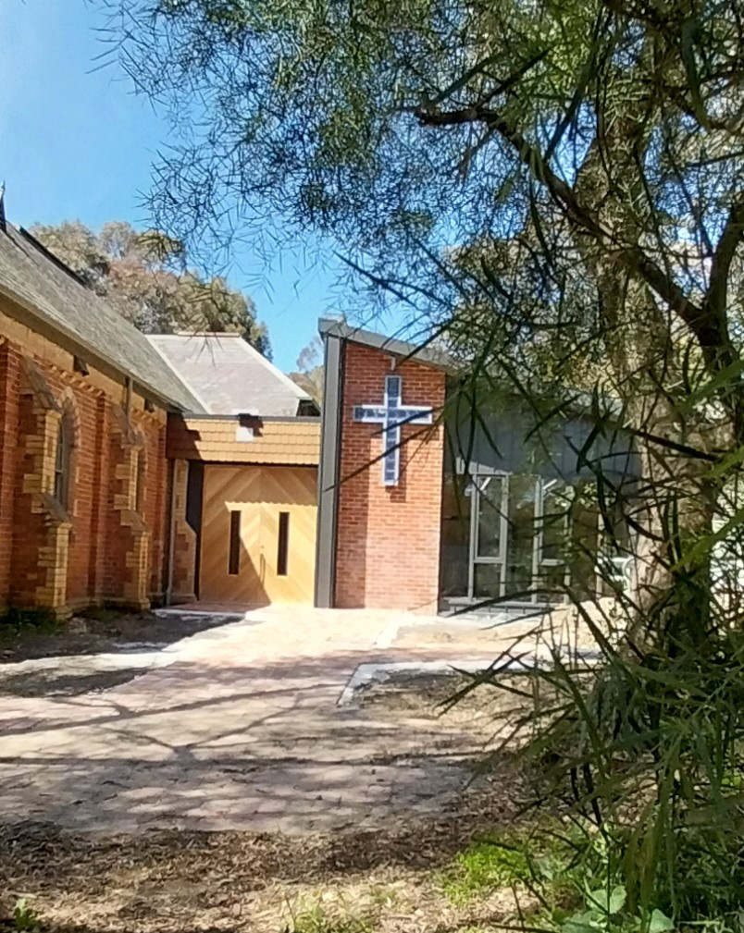

***810 Main Road, Eltham***

[www.elthammontmorencyuca.org](http://www.elthammontmorencyuca.org)

**Worshipping on Sundays @ 9.30am**

**Rosters 10th November 17th November**

Worship Leader Paul Chandler Paul Miles

Vestry Assistant Merilyn Jen

Welcome Theo Natalia

Bible Readings Jamie Jan N

Prayers o/t People Natalia Andrea

Sound Steve & Natalia Steve & Annette

Music Elizabeth Elizabeth

Morning Tea May & Leo Rex & Gwenda

Lock Up Steve Rex?

Flowers Jan N Jen

Counting Maree & Heather Steve & Bill

**10th November, 2024**

**Leader this week:**

Paul Chandler

**Lectionary Readings:**

Ruth 3:1-5; 4:13-17

and Psalm 127

1 Kings 17:8-16 and Psalm 146

Hebrews 9:24-28

Mark 12:38-44

**Welcome to our newsletter**

**Working Bee: This Saturday:**

From 10am onwards: To move and spread mulch. Tools are available but another wheelbarrow would be helpful. Thanks, Jim

………………………………………………………………………………………

**Sammy Stamp is Back!**

The box for stamps for Sammy Stamp is on the entrance table.

Please remember to collect and save your stamps. For further details see Cathie R.

…………………………………………………………………………………………

**Coffee Mornings:**

It has been decided that the coffee mornings will recommence in the New Year.

……………………………………………………………………………………….

**Coming Up in November:**

Monday 11th: Church Council: 7.30pm @ the church

Saturday 16th: Food for Thought: 10.30am

Monday 18th: Birthday Lunch: 12noon @ Monty RSL

Tuesday 19th: Reading/ Discussion Group: 1pm

Thursdays: Reflections: Every Week: 9.30am @ the church

**A Great Cloud of Witnesses:**

Attached is an extract for a new occasional series from Ken.  The aim is to mark our return to the refurbished church. Many thanks, Ken.

…………………………………………………………………………………………….

**MASSG Refugee News:**

Welcome a Refugee Family

Montmorency Asylum Seeker Support Group (MASSG) and Community Refugee Sponsorship Australia (CRSA) warmly invite you to an inspiring and informative community event in Eltham.

Join us to learn about community refugee sponsorship, the transformative impact it is having on refugee newcomers and local communities and how you can take an active and important role in welcoming refugees.

Refugee sponsorship is a new opportunity for Australians to make a real difference in the lives of refugee newcomers, providing a soft landing and support under the Community Refugee Integration and Settlement Pilot (CRISP). It offers practical and meaningful assistance to refugee households as they establish and navigate their new lives in Australia.

[Watch this video for a brief insight into the program](https://youtu.be/r2LB9gE6vto)

 When/Where:             14th November, 7pm – 8.30pm

      Eltham Living & Learning, Eltham War Memorial

                                        907 Main Road, Eltham

Hosted by:  Montmorency Asylum Seeker Support Group (MASSG) and Community Refugee Sponsorship Australia (CRSA)

Click [HERE](https://zfrmz.com.au/NEuN9EVJ80jLoO01cReJ) to register your attendance.

Barbara Jackson 0406588417

On behalf of the Montmorency Asylum Seeker Support Group

P.S. The October edition of Crosslight features an article on CRISP on pages 26 -29.

……………………………………………………………………………………………

***For any***

***pastoral care concerns please contact Fiona on 0417 164 503***

Items for newsletter……Please send items to Heather by 8pm Thursday. Ph. 94391882 or email heatherjoy20@hotmail.com